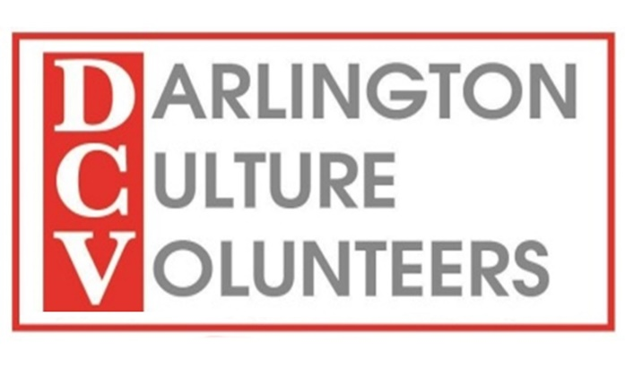
EXPRESSION OF INTEREST IN VOLUNTEERING WITH DARLINGTON CULTURE VOLUNTEERS
Please submit your completed form electronically to the Volunteer Co-ordinator at darlingtonculturevolunteers@hotmail.com or post it to Hippodrome HQ, 20-22 Horsemarket, Darlington, DL1 5PT. A copy of this form can be downloaded darlingtonhippodrome.co.uk
Thank you for expressing an interest in volunteering with Darlington Culture Volunteers.

Your details
Title (Mr/Mrs etc.)

First Name

Surname/Family Name
Address
Post Code

Date of Birth

Home Telephone Number
Mobile Phone Number
Please tell us when it is convenient to ring you and which number you prefer us to use.
E Mail Address
(if you have one)
On receipt of this form we will contact you to explain more about the work we do and explain the next steps. We look forward to working with you.

